Electronic Retail Sales Dashboard Using Power BI

Name : Dharshini
Roll No : E25FA053
Course : B.com fintech and AI

Introduction
This project is a sales dashboard built in Microsoft Power BI for an electronic retail business. The business sells products such as mobile phones, laptops and televisions through online and physical stores across several Indian cities, so its data is large and spread over many dimensions. Reading such data row by row makes it hard to see how the business is really doing.
The aim of the dashboard is to turn the raw sales data into clear visuals. It shows total revenue, profit, quantity sold and number of orders in KPI cards, and breaks them down by product category, city, store, store type and month. A store performance table adds detail for every individual store.
Interactive slicers let a user filter the whole page by product category, year, customer segment, store type and state. In this way the same dashboard can answer many different business questions without building a new report each time.
Overall, the project shows how Power BI can be used to study retail data, spot trends, compare performance and support better business decisions.
Objectives of the Project
The dashboard was built to meet the following objectives:
- To study the overall sales performance of the electronic retail business.
- To track key figures such as Total Revenue, Total Profit, Total Quantity and Total Orders.
- To compare the revenue earned by each product category.
- To find out which cities bring in the most revenue.
- To see how profit is spread across product categories.
- To understand how much each type of store contributes to revenue.
- To compare the performance of individual stores.
- To observe how revenue changes from month to month.
- To give store-level revenue and profit details in an interactive table.
- To use slicers that filter the data by product category, year, customer segment, store type and state.
- To convert raw sales data into insights that help in planning and decision-making.

Dataset Description
The dataset holds sales records of an electronic retail business covering products, customers, stores, orders and transactions. Each record carries the details needed to measure revenue and profitability.
The main fields used in the dashboard are:
- Product category: Accessories, Audio, Home Appliances, Laptops, Mobile Phones, Televisions and Wearables.
- Location fields: city name, state and store name, used to study regional sales and store performance.
- Store type: Online, Urban, Flagship, Mall and Suburban.
- Customer segment: groups such as Premium, Regular and Occasional customers.
- Sales measures: order quantity, sales revenue, profit and order details.
- Date fields: full date, month name and year, used for trend analysis. The data covers the years 2024 to 2026.
Power BI was used to load, clean and organise this data. Measures were created to calculate totals such as revenue, profit, quantity and order count, and these feed the KPI cards and charts.
While building the dashboard, two data-quality issues were noticed. Store type contains both "Urban" and "urban", and customer segment contains both "PREMIUM" and "Premium". These are the same values typed in different cases, so they appear as separate entries in the donut chart and slicers. Standardising them in Power Query would make the figures more accurate.
Dashboard Components and KPI Cards
Key Performance Indicators (KPIs) give a quick summary of the business at the top of the dashboard, so a user does not need to open every chart to understand the overall position. The dashboard has four KPI cards.
- Total Quantity
The Total Quantity card shows about 112K units sold. It measures sales volume and shows overall product demand. It also helps in planning stock and inventory.
- Total Orders
The Total Orders card shows about 15K orders. It reflects how many purchases customers made and can be compared across stores, periods and customer segments.

- Total Profit
The Total Profit card shows about $979.89M. This is the gain left after costs in the dataset are deducted, and it shows how profitable the business is overall.
- Total Revenue
The Total Revenue card shows about $4.71bn. It is the total value of sales and is the main indicator of business size. Comparing it with profit shows how much of each sale turns into earnings. Profit is about 20.8% of revenue (979.89M divided by 4.71bn, calculated for this report).
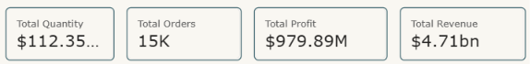

Dashboard Charts and Visualizations
Each chart on the dashboard answers a separate business question. Insert the matching screenshot from your Power BI file under each heading.
- Revenue by Product Category (Column Chart)
This column chart compares revenue across the seven product categories. Mobile Phones earn the most at about $1.77bn, followed by Laptops at $1.46bn and Televisions at $0.93bn. Home Appliances add $0.31bn, Audio $0.16bn and Wearables $0.08bn. Accessories contribute almost nothing. The chart makes it clear that phones, laptops and televisions drive most of the sales.
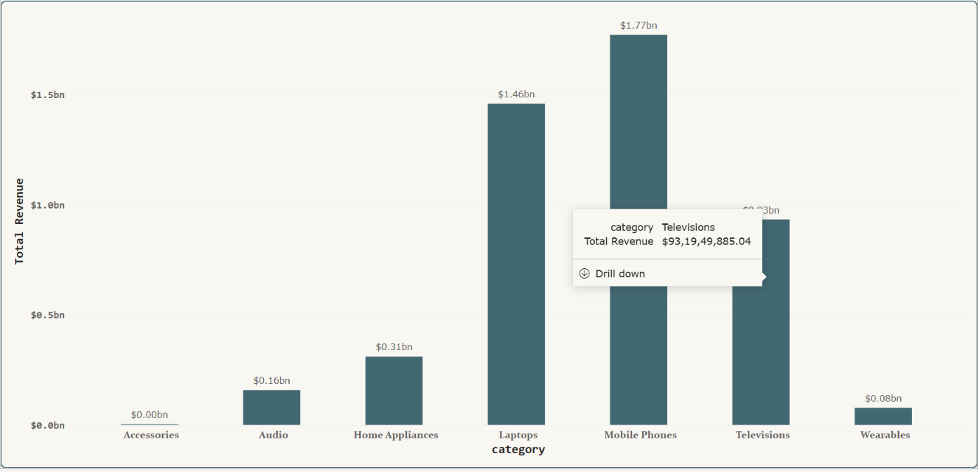

- Total Profit by Category (Tree Map)
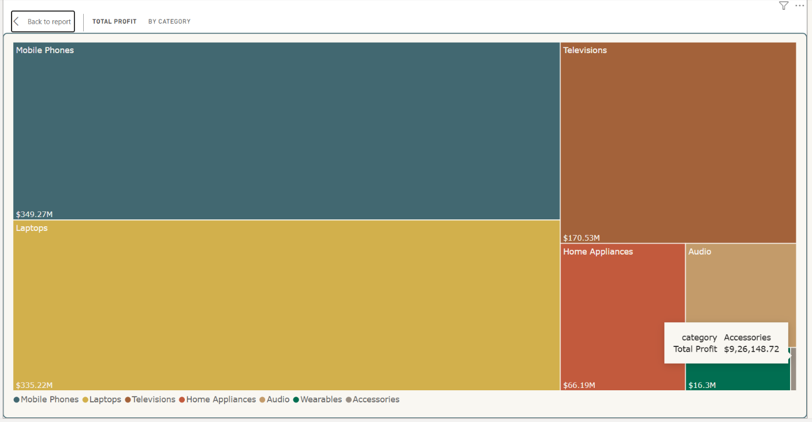
The tree map shows each category as a rectangle sized by its profit. Mobile Phones lead with about $349.27M and Laptops follow closely at $335.22M. Televisions give $170.53M, while Home Appliances, Audio and Wearables take much smaller blocks. Because box size shows the share, the biggest profit contributors can be seen at a glance.

- Revenue by Store (Bar Chart)
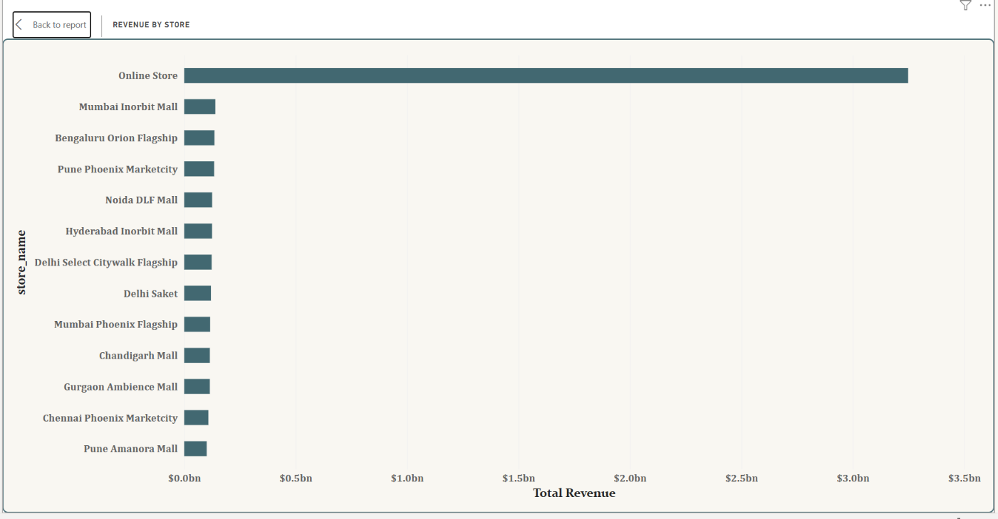
This bar chart compares revenue of individual stores. The Online Store is far ahead, with revenue above $3bn, while each physical store such as Mumbai Inorbit Mall, Bengaluru Orion Flagship and Pune Phoenix Marketcity earns a much smaller amount. It highlights how important the online channel is to the business.
- Revenue by City (Bar Chart)
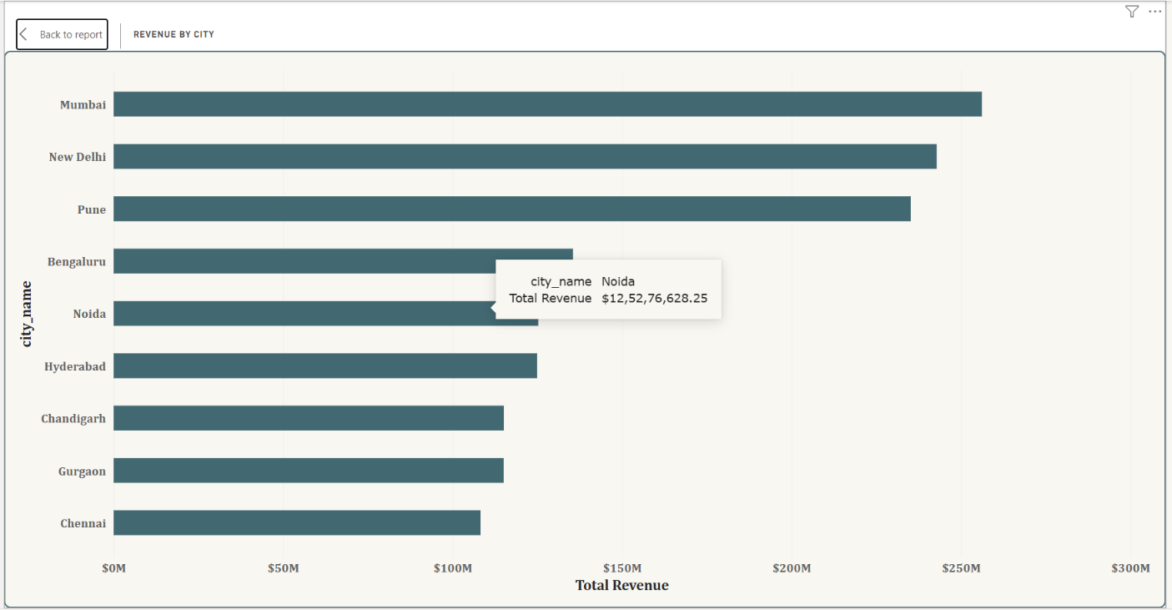
This chart ranks cities by revenue. Mumbai, New Delhi and Pune are the top three, each at roughly 0.23 to 0.26bn. Bengaluru comes next at about 0.13bn. Noida, Hyderabad, Chandigarh, Gurgaon and Chennai earn around 0.10 to 0.12bn each. This helps in choosing where to expand stores or focus marketing.

- Revenue Distribution by Store Type (Doughnut Chart)
The doughnut chart shows each store type's share of the $4.71bn total.
Store type | Revenue ($bn) | Share of total
Online | 3.25 | 69.02%
Urban | 0.63 | 13.32%
Flagship | 0.38 | 7.97%
Mall | 0.22 | 4.59%
urban (lowercase entry) | 0.12 | 2.45%
Suburban | small remainder | about 2.65% (calculated)
Online sales make up more than two-thirds of revenue. The separate lowercase "urban" entry is a data-entry inconsistency, and if merged with "Urban" the urban share would be about 15.8%.

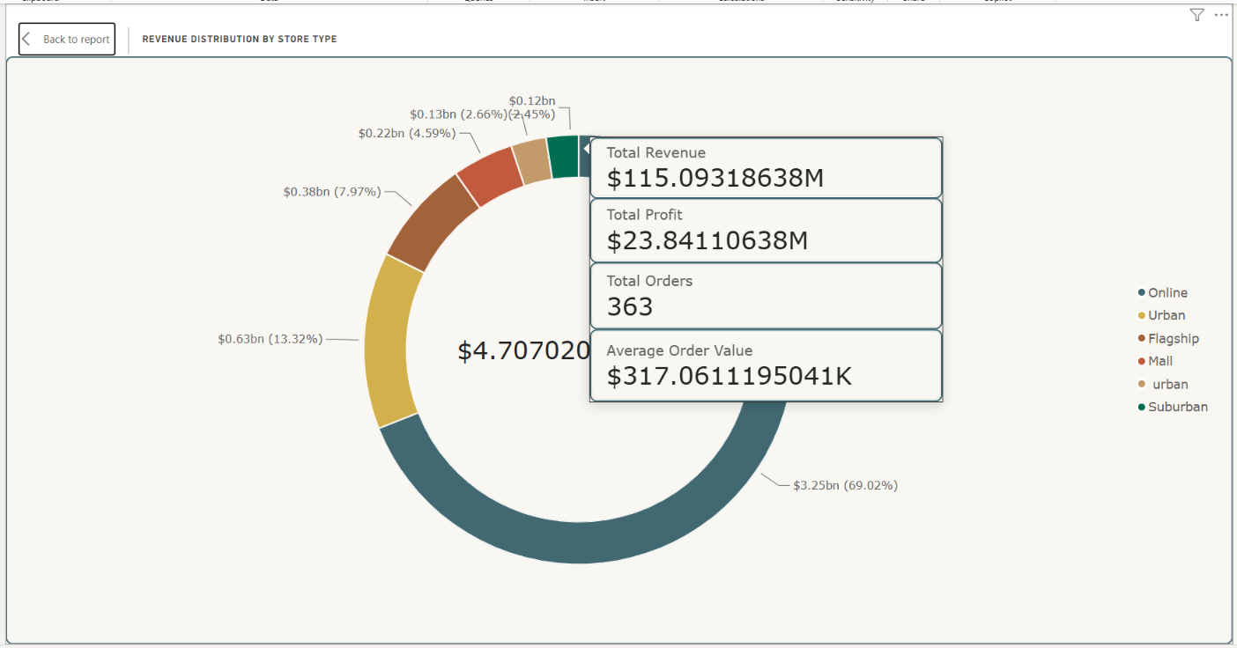
- Total Revenue by Month (Line Chart)
The line chart shows how revenue moves through the year. Revenue starts near $330M in January and falls to its lowest point of about $305M in February. It then climbs to around $365M in March and stays near $360M to $375M in April and May. It rises again through June and reaches about $435M in July and August, dips in September, and peaks at about $485M in October. It then eases to roughly $435M in November and $415M in December.
The second half of the year is clearly stronger than the first, with the highest sales in October. This pattern is useful for planning stock, promotions and festival-season offers.
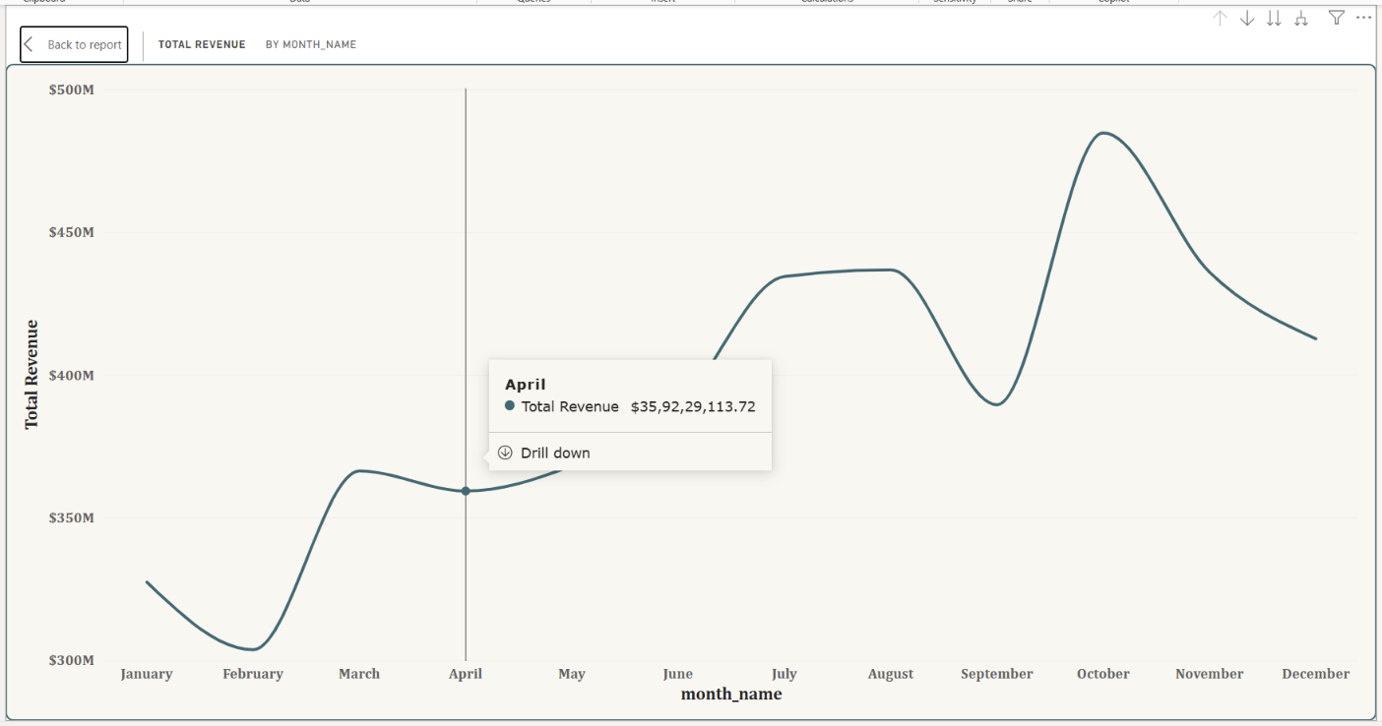
Store Performance Table
The store performance table gives exact revenue and profit for every store, along with a small trend line for each. Its columns are Store Name, Total Revenue, Total Profit and a sparkline of revenue over time.
Sparklines are tiny line charts placed inside the table. They show whether a store's revenue is rising, falling or irregular without needing a separate chart for each store.
Some stores visible in the table are:
Store | Total Revenue | Total Profit
Mumbai Inorbit Mall | 13,96,86,423.45 | 2,88,14,583.45
Hyderabad Inorbit Mall | 12,49,42,355.39 | 2,54,34,815.39
Delhi Select Citywalk Flagship | 12,29,93,960.70 | 2,52,28,110.70
Gurgaon Ambience Mall | 11,50,93,186.38 | 2,38,41,106.38
Total (all stores) | 4,70,70,20,747.02 | 97,98,91,147.02
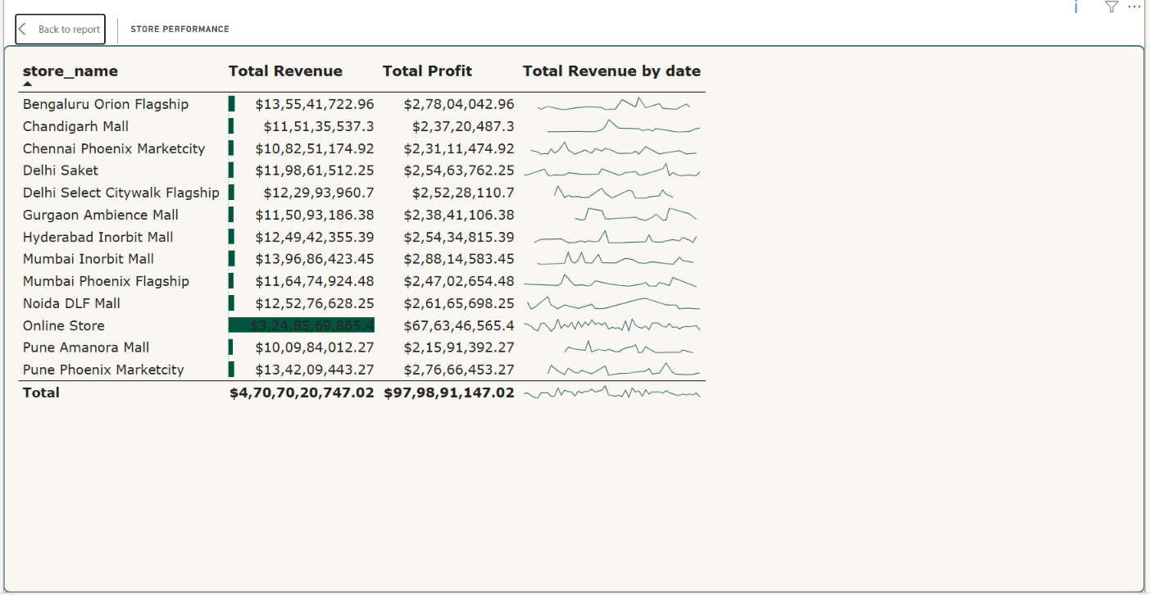
The total row matches the KPI cards, at about 4.71bn revenue and 979.89M profit. Among the physical stores shown, Mumbai Inorbit Mall earns the highest revenue and profit. The table helps managers compare stores and find those that need more marketing or operational attention.

Slicers and Filters
Slicers are interactive filters in Power BI. When a user selects a value, the KPI cards, charts and table update to show only matching data. This dashboard has five slicers.
- Product Category Slicer
Filters the dashboard by category, such as Accessories, Audio, Home Appliances or Laptops. It shows how one product group performs across cities, stores and months.
- Year Slicer
A slider covering 2024 to 2026. Users can pick a single year or a range to compare performance over time.
- Customer Segment Slicer
Filters by customer group, such as Premium, Occasional and Regular. It shows how much each type of customer contributes to sales.
- Store Type Slicer
Filters by sales channel, such as Online, Flagship, Mall and Urban. It allows a direct look at how each channel performs.
- State Slicer
Filters by state, for example Delhi, Haryana, Karnataka, Maharashtra and Tamil Nadu, plus an Online / National option. It supports regional performance analysis.
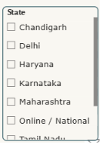
Slicers can be combined. For example, a user can select 2025, Karnataka, Mall stores and Laptops to see only that combination. This makes the dashboard flexible and avoids the need for separate reports.
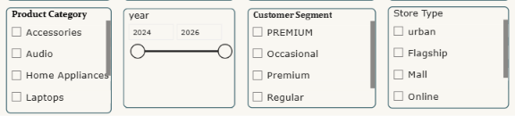
Insights from the Dashboard
The dashboard leads to these main observations:
- The business earned about $4.71bn in revenue and $979.89M in profit, a profit share of roughly 20.8%.
- About 112K units were sold across roughly 15K orders.
- Mobile Phones are the top category in both revenue ($1.77bn) and profit ($349.27M), with Laptops second in both.
- Mobile Phones, Laptops and Televisions together produce most of the revenue, while Wearables and Accessories add very little.
- Mumbai, New Delhi and Pune are the three highest-earning cities.
- Online sales bring in about 69% of total revenue, and the Online Store is by far the largest single store.
- Revenue is lowest in February and highest in October, with the second half of the year stronger than the first.
- Physical stores earn similar amounts to each other, in the range of about 10 to 14 crore per store in the table, so the online channel is the main growth driver.
- Inconsistent spellings such as "Urban" and "urban" need cleaning so that the figures are not split.

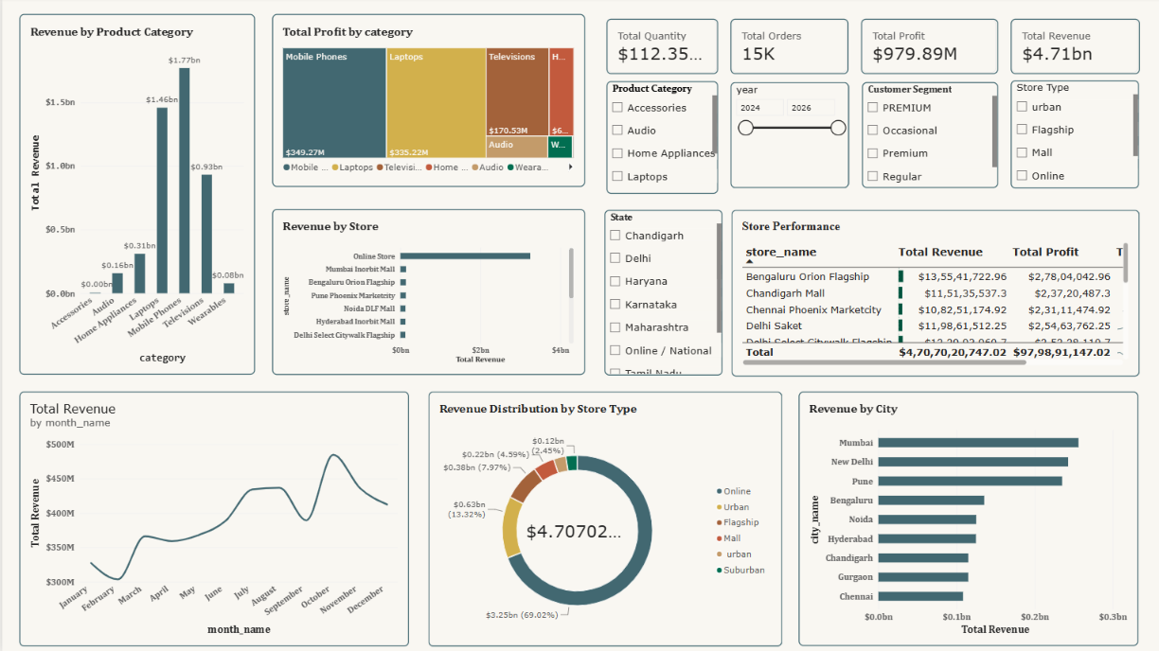

Importance of the Dashboard in Retail Analysis
A retail business has to watch sales across products, locations, customers and channels at the same time. Doing this with plain spreadsheets is slow and easy to get wrong. A dashboard brings all of these views onto one page.
This dashboard shows which categories earn the most, which stores and cities perform best, and how important online sales are. It also shows profitability and the monthly pattern of revenue. Because the slicers let users narrow the view, managers can study a single region, year or customer group in a few clicks.
Such information can support sales strategy, inventory planning, store expansion, regional comparison and marketing decisions.

Conclusion
The Electronic Retail Sales Dashboard shows how Power BI can be used to analyse and present retail data. It brings together revenue, profit, quantity and orders, and breaks them down by category, city, store, store type and month.
Each visual serves a purpose. The column chart compares categories, the tree map shows profit share, the bar charts rank cities and stores, the doughnut chart shows channel contribution, and the line chart tracks monthly revenue. The store table adds exact figures and sparklines, and the five slicers make the whole page interactive.
The analysis shows that Mobile Phones and Laptops lead in both revenue and profit, that Mumbai, New Delhi and Pune are the strongest cities, and that online sales provide about 69% of revenue. Overall, the project shows how raw sales data can be turned into clear insights that support better business decisions.

